# CS 255 System Design Document Template

## UML Diagrams

### UML Use Case Diagram

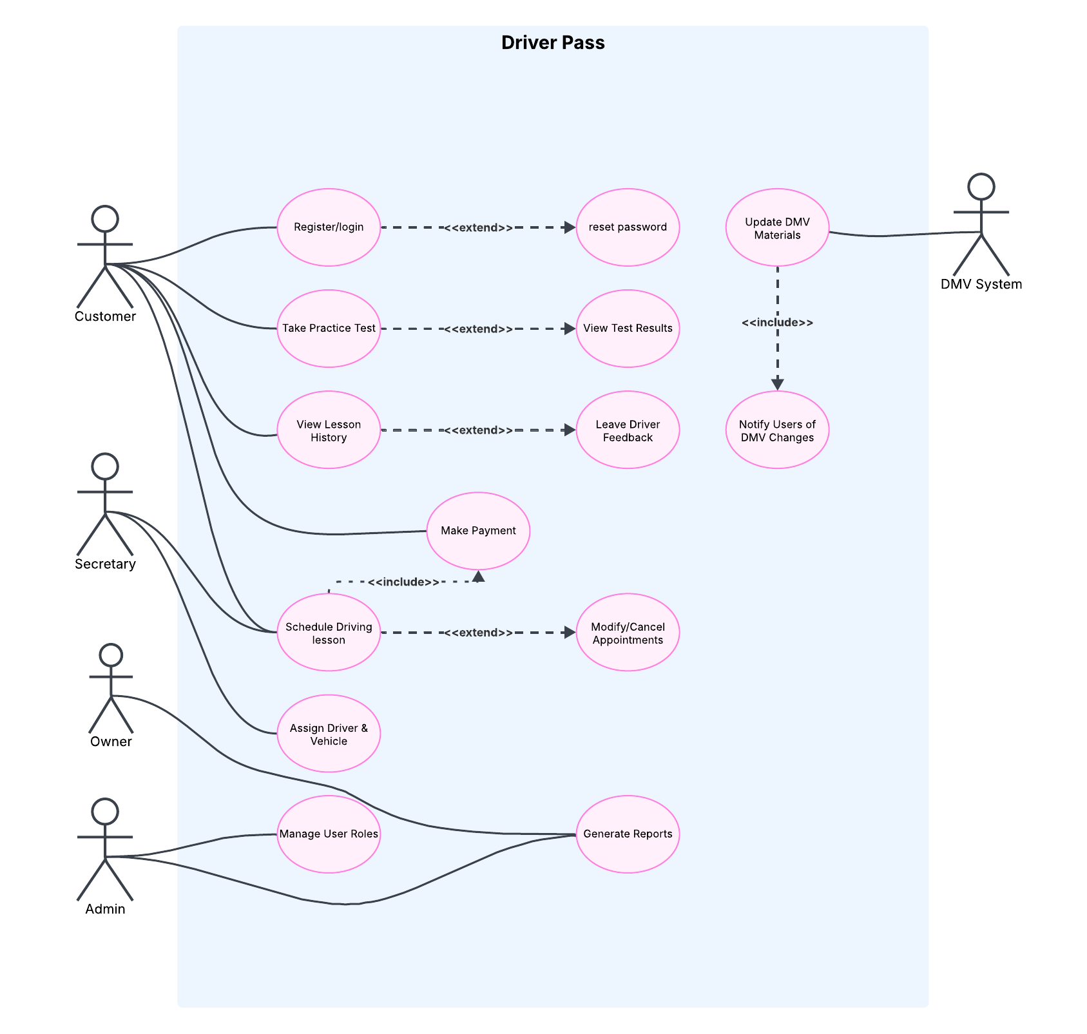

### UML Activity Diagrams

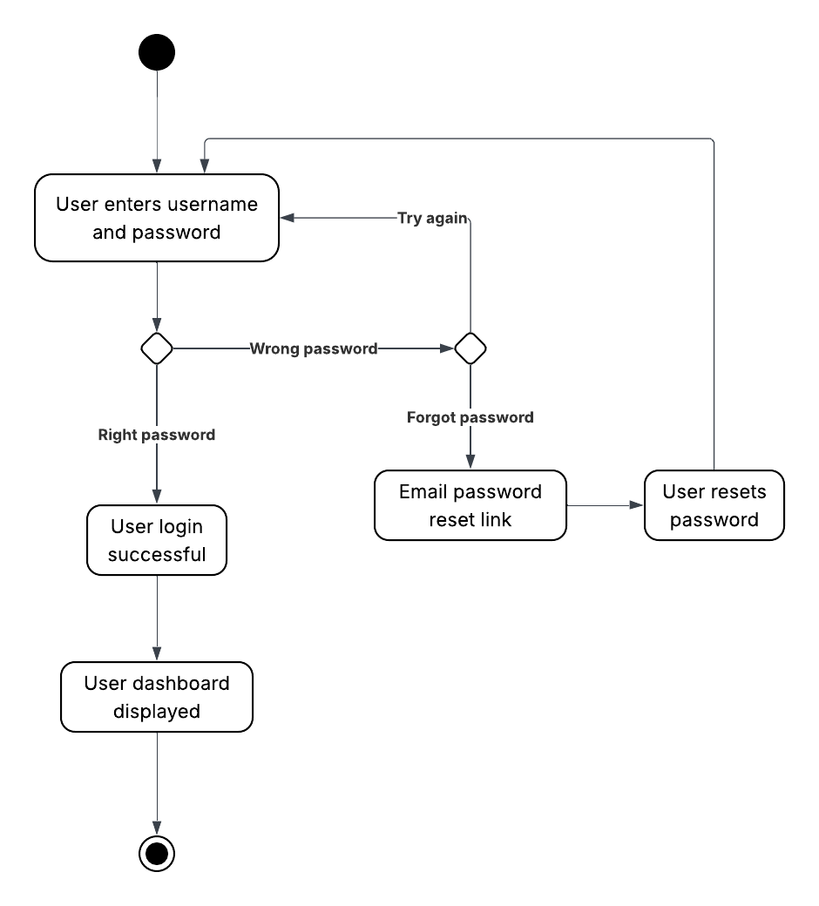

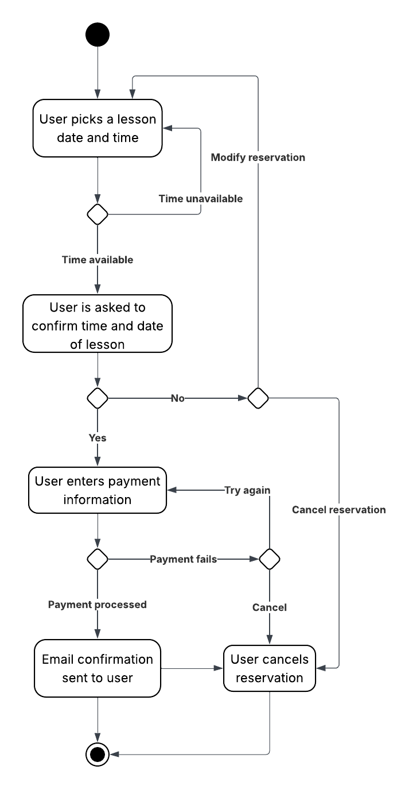

### UML Sequence Diagram

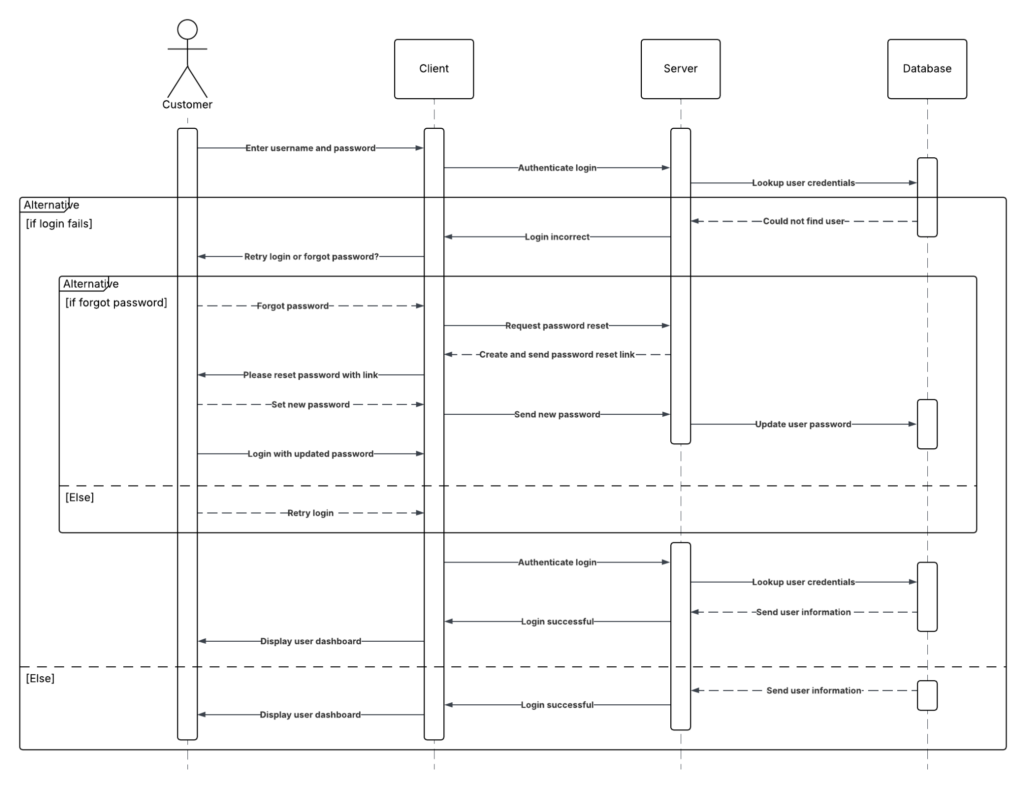

### UML Class Diagram

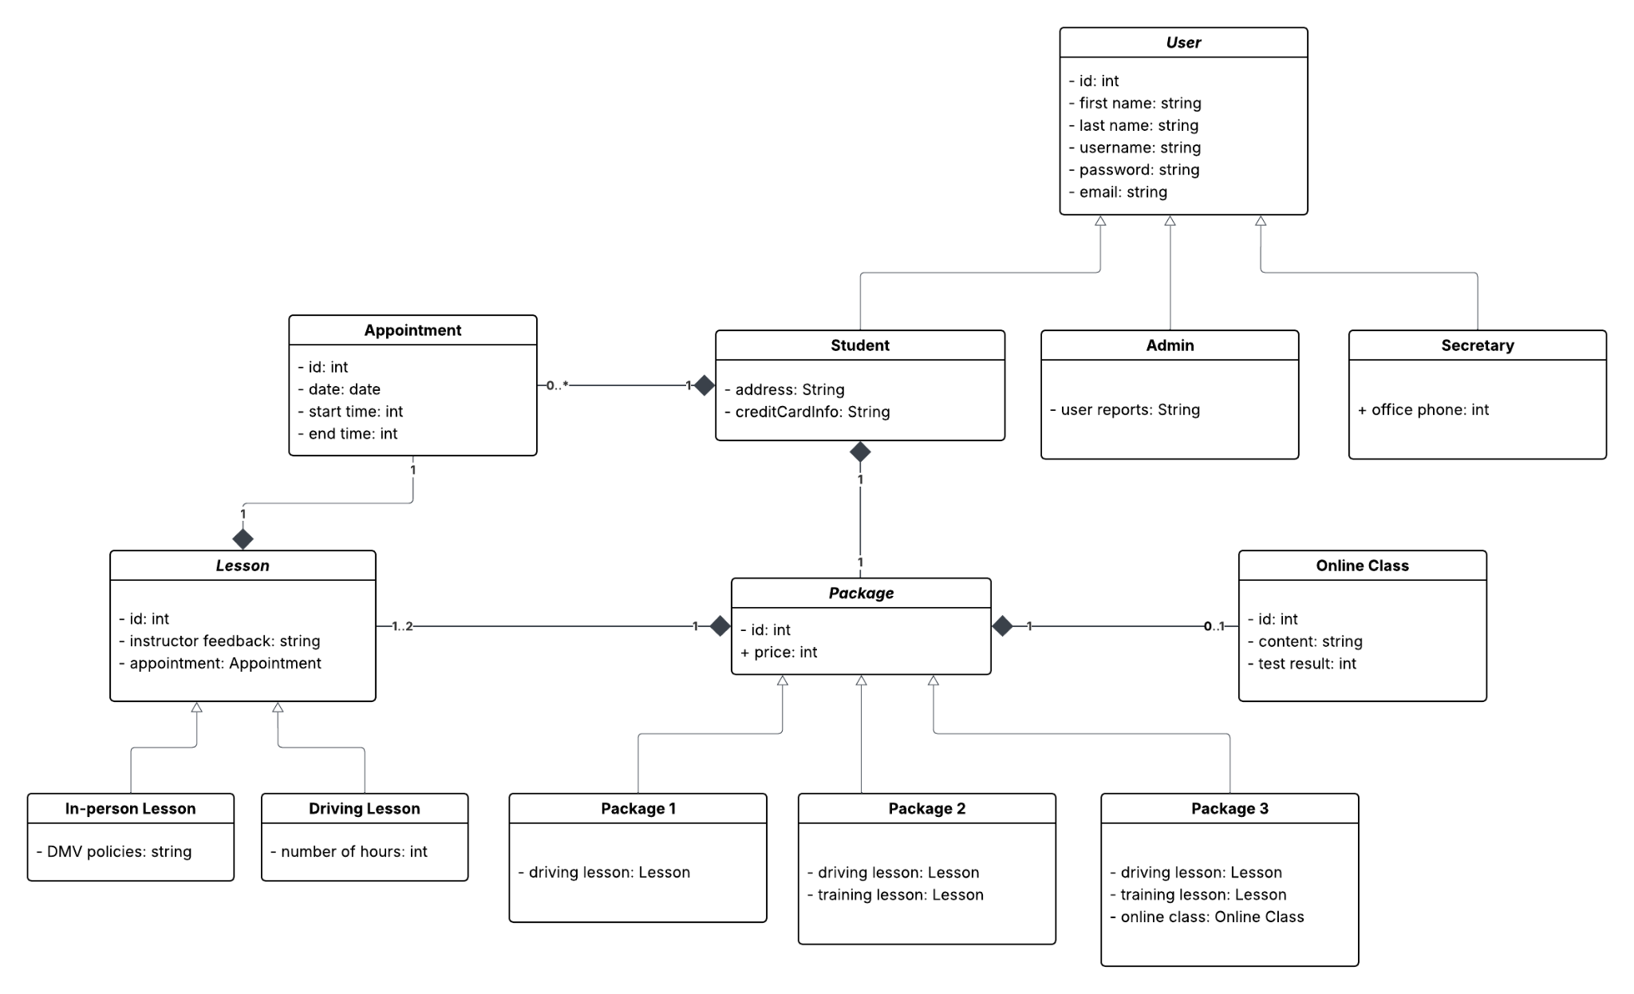

## Technical Requirements

The hardware needed for the system includes a main server where the system will be hosted on. The main server should be located somewhere secure like a locked room that can only be accessed by DriverPass staff who have a key or ID card required for entry. The building the servers are located in should have cameras and an alarm system. There should be a router the servers can connect to have access to the internet since it is a cloud-based application. The building should also have backup power available in case of a power outage and additional servers that maintain an up-to-date backup of the application data to recover to if the main server goes down. Each customer that uses the system will need internet access and a personal computer or mobile device with a web browser installed.

The software requirement is either an up-to-date Linux or Windows operating system installed on the main server that can serve a web application and host a database. The web application software can be in any commonly used and reliable language for web development, like Python or Java. The database software can also be any commonly used and reliable one like MySQL or PostgreSQL.